for i in range(640):

for j in range(480):

if(color_image[i][j][0]>color_image[i][j][1] and color_image[i][j][0]>color_image[i][j][2]):

color_image[i][j][0] = 255

color_image[i][j][1] = 0

color_image[i][j][2] = 0

elif(color_image[i][j][1]>color_image[i][j][2]):

color_image[i][j][0] = 0

color_image[i][j][1] = 255

color_image[i][j][2] = 0

else:

color_image[i][j][0] = 0

color_image[i][j][1] = 0

color_image[i][j][2] = 255  
execution time 1 second. 1 SECOND FOR 1 000 000 OP. Is it joke?  
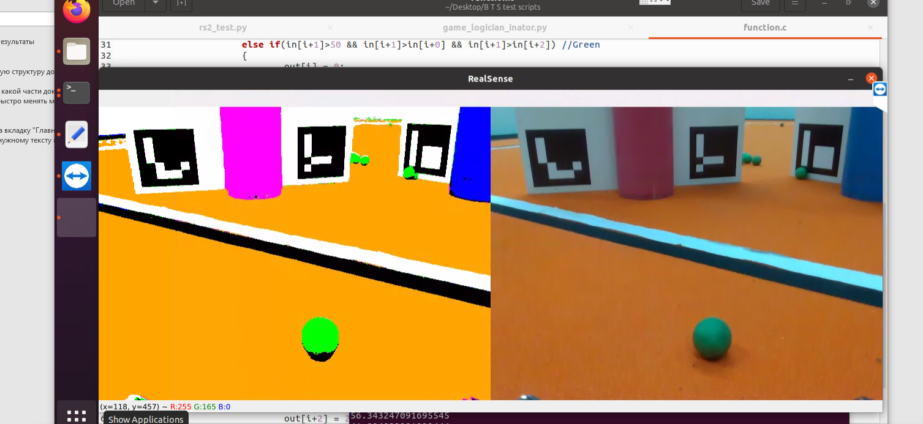  
Dummy recoloring in C. 60 fps remains

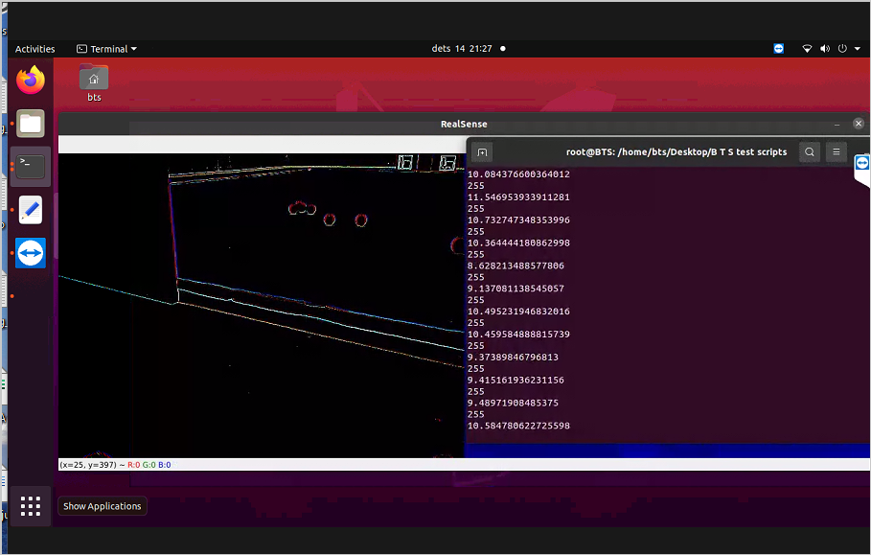

Countur mask in python (with library) low fps

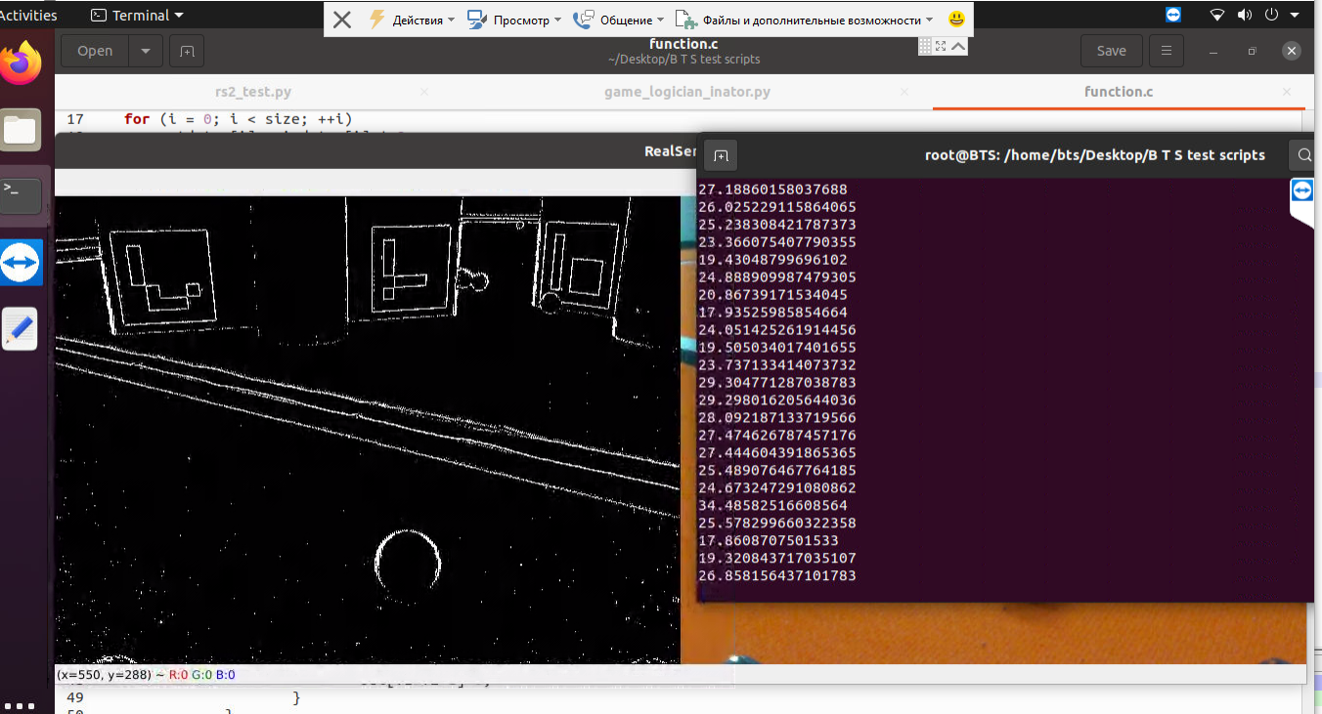

My same function in c without improvement has better performance. Good joke.